AC10V4.0 Upgrade Note
Hardware Version: V4.0
Software Version: V16.03.10.09
Upgrade Notes:
- This firmware is only fit for AC10V4.0 and its firmware version must be in V16.03.10.XX or more.
Note: The hardware version marked at the lable of devices as below:
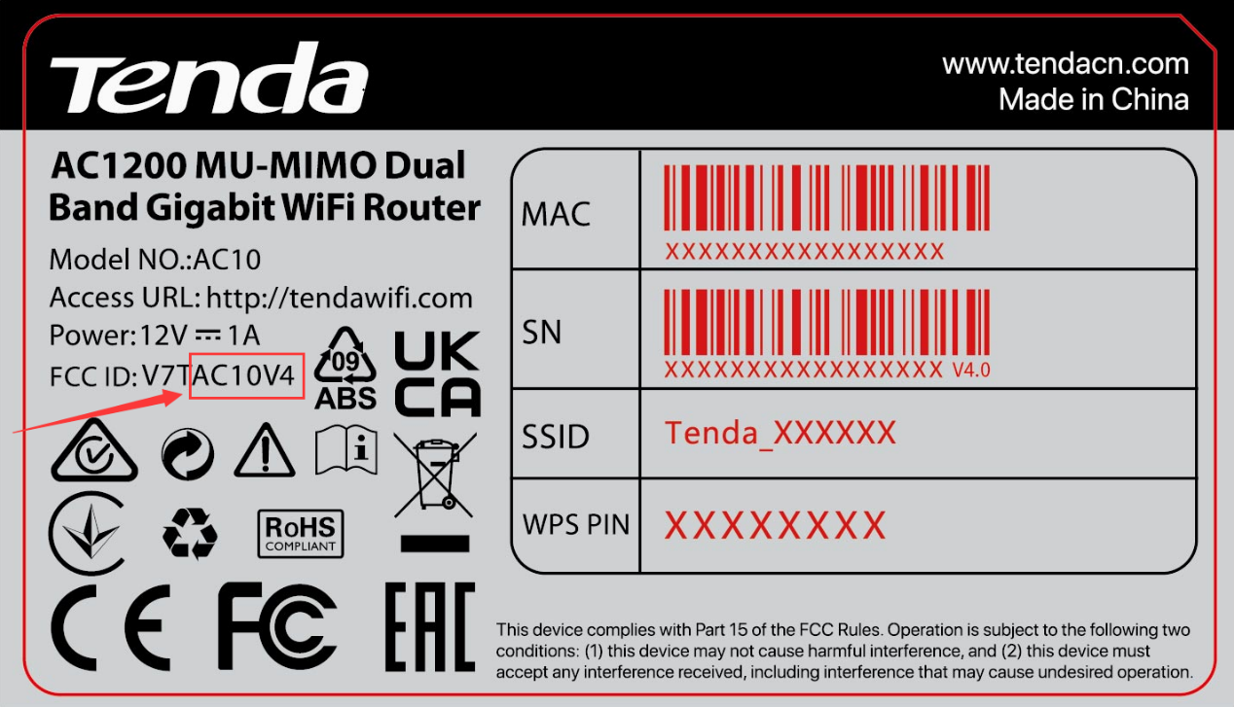
- Do not power off the device when upgrading.
- Please unzip the file you downloaded and use the file ended with "bin" or "trx" to upgrade your device.
- Please reset it to factory settings after upgraded it.
Release Notes:
- Solved the issue that slow speed on some of phone due to unstable negotiation.
- Solved the issue that parts of cameras cannot get connected.
- Solved the issue that parts of adapters cannot obtain IP even show connected successfully.
- Optimized the LED status for different situations.

